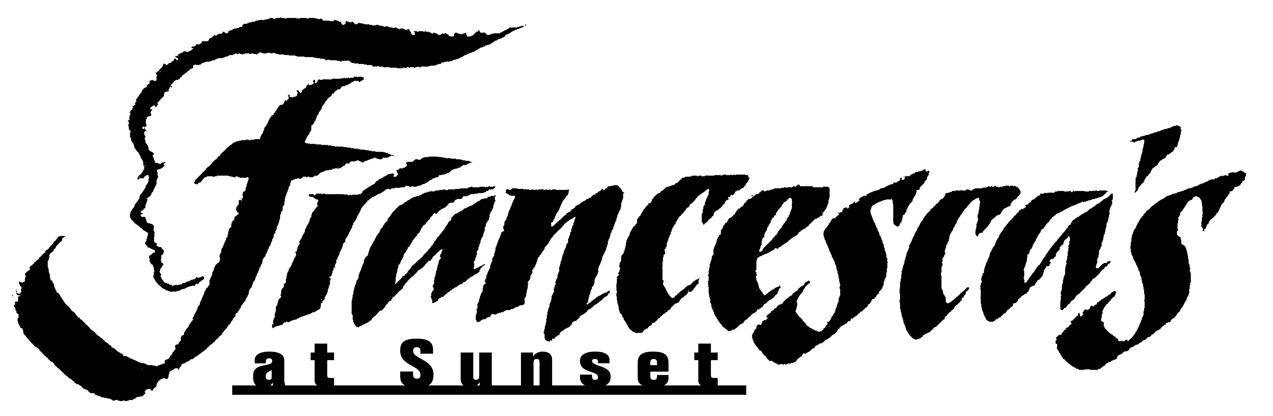

Breakfast with Santa
Dec. 8, 14, 15, 21 & 22 from 8:00am-11:00am
For reservations call the resort concierge at 210-558-2439.

Mini Smoked Salmon Bites with Bagel Chips and Cream Cheese

Granola, Strawberry Yogur and Maple Syrup Shooters

Sausage Links

Turkey Sausage Patties

Scrambled Eggs

Egg White Frittata

Applewood Bacon

Grilled Ham

Oatmeal with sliced bananas, pecans and honey

English Muffin Egg Cheese Pizza

Ham and Cheese Panini

Hash Browns

Quiche

Mixed Fruit

Selection of Fresh Juices

Hot Cocoa Station

Assorted Pastries

$25.00* for adults / $12.50* for children
*Tax and gratuity are not included in this price.

